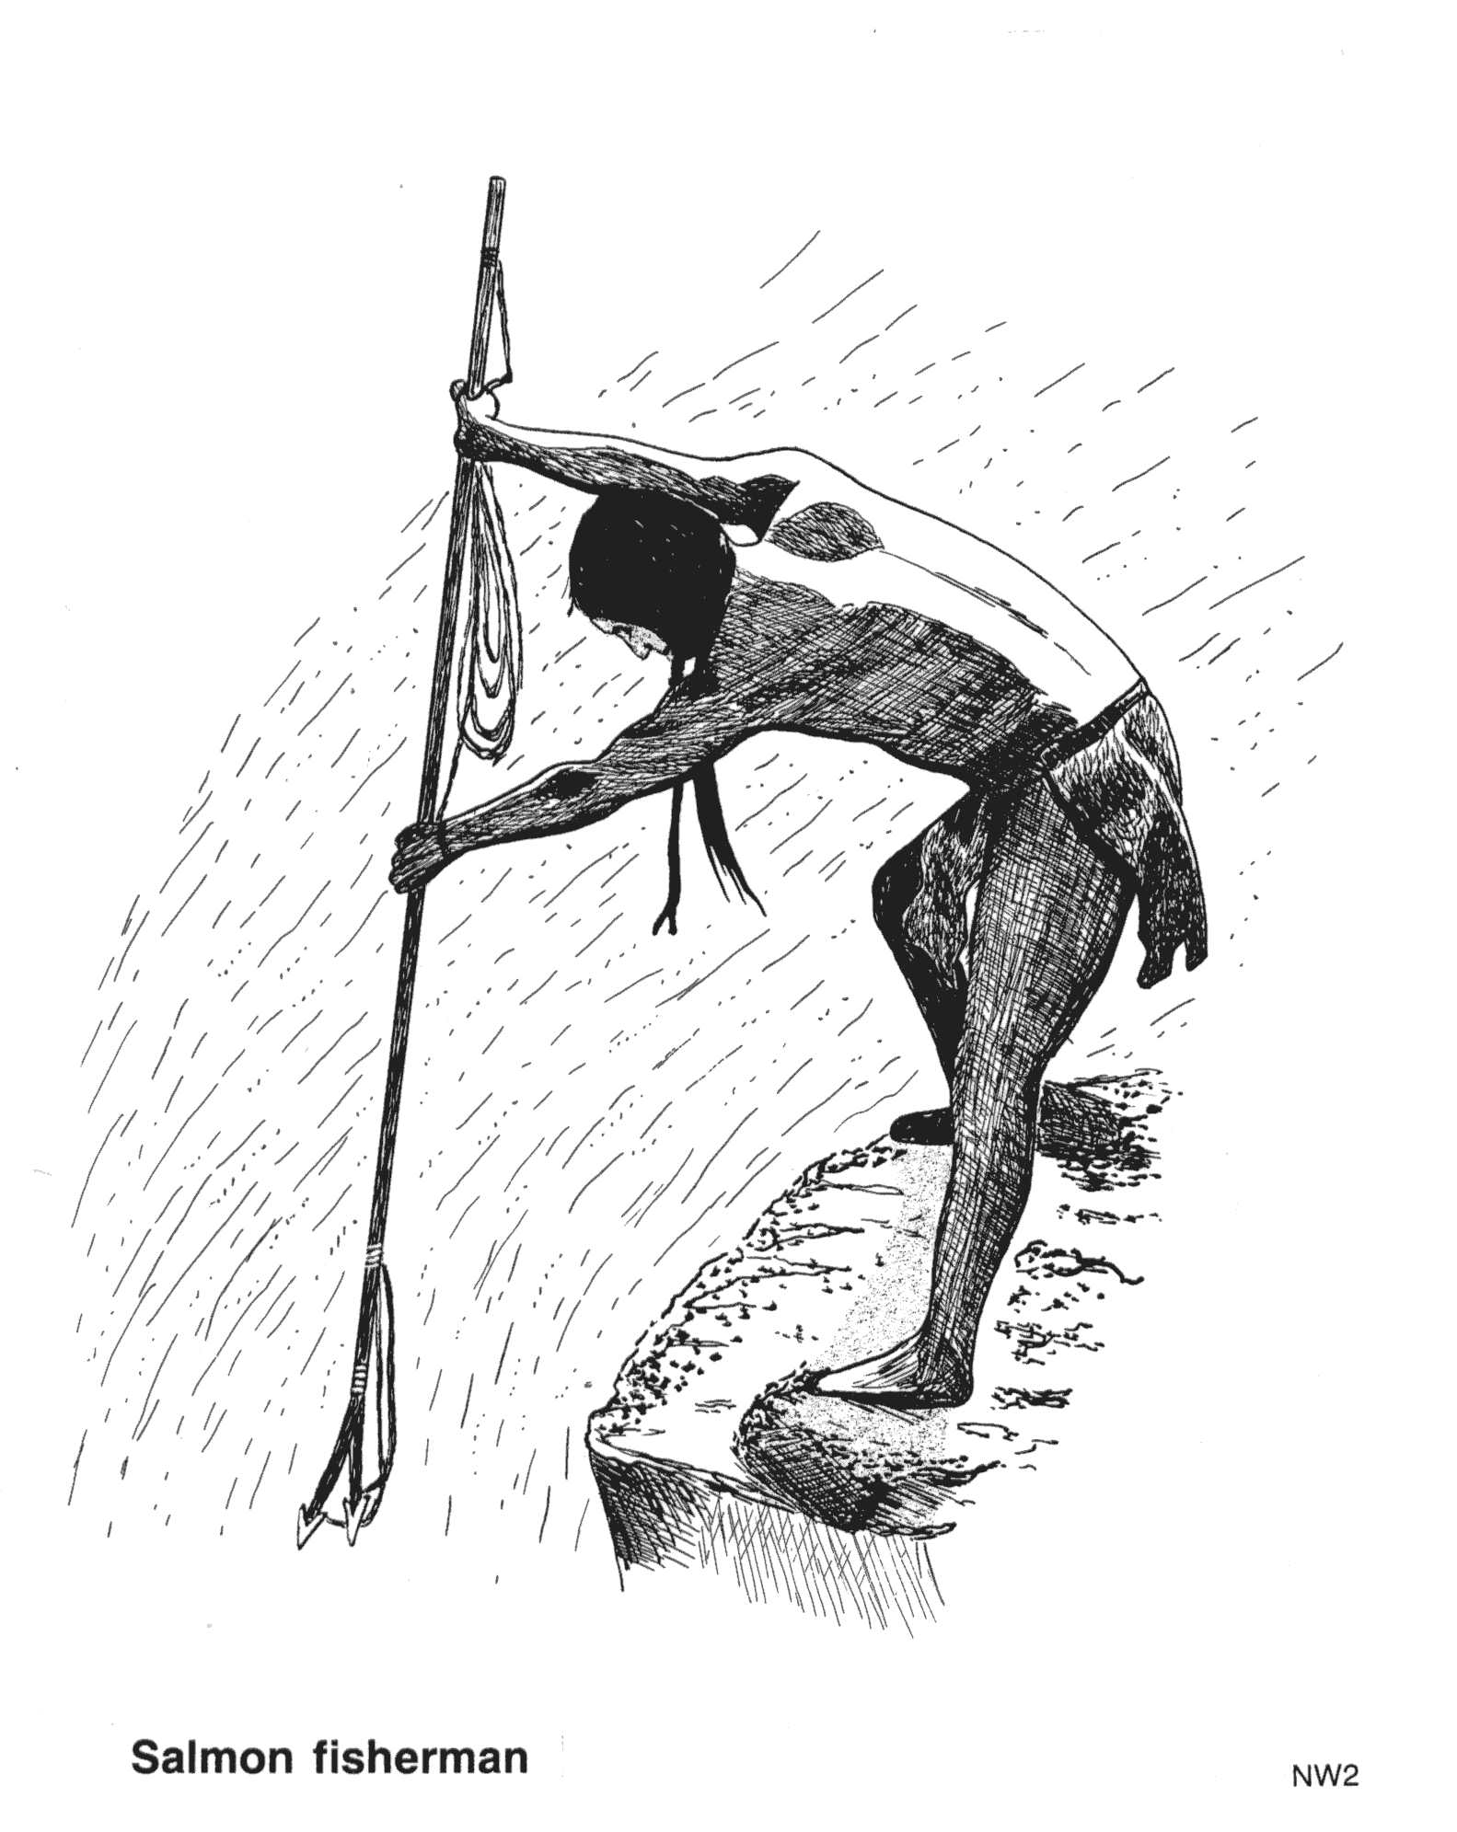

Squamish Chief 4 brothers

Snookum Salmon people

Squamish people Salmon Chief (Spring Salmon)

2 boys, 2 girls

Plot Outline

Assignment:

Create a one-page summary of the story

Follow these criteria:

Describe each character:
  - Squamish Chief
  - 4 supernatural brothers
  - Snookum
  - Squamish people
  - Salmon people
  - Salmon Chief (Spring Salmon)
  - Two boys, two girls

  - Create a short plot outline, including an introduction, rising action, climax and conclusion

  - Produce an illustration that captures the meaning of the story using colour and creativity.

